HW2：
part1，讀取影像後可依自行輸入的閾值做二值化轉換。
part2，實現shrinking and expanding。
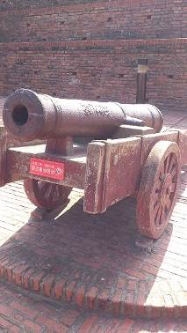
程式碼：
clc;clear;
%% part.1
[FN] = uigetfile({'*.jpg','JPEG (*.jpg;*.jpeg;*)';...
'*.png','PNG (*.png)';...
'*.bmp','BMP (*.bmp)'},'開啟圖檔');
% Binarization
% rgb = imread('apple.jpg');
rgb = imread(FN);
threshold = input('請輸入閾值:'); %輸入閾值(0~255)
threshold = threshold / 255; %設定閾值
Binary = im2bw(rgb,threshold); %二值化轉換
% figure(1); imshow(rgb);
% figure(2); imshow(Binary);
%% part.2
% 膨脹和侵蝕（imerode和imdilate）
exp_imgA = zeros(size(Binary)); %水平處理LR
exp_imgB = zeros(size(Binary)); %垂直處理UD
exp_imgC = zeros(size(Binary)); %水平處理RL
exp_imgD = zeros(size(Binary)); %垂直處理DU
% expanding
for i=1:size(Binary,1);
for j=1:size(Binary,2);

if j < size(Binary,2)-2
if Binary(i,j)==0 & Binary(i,j+1)==0 & Binary(i,j+2)==0 & Binary(i,j+3)==0
exp_imgA(i,j) = 0;
else
exp_imgA(i,j) = 1;
end
end

if i < size(Binary,1)-2
if Binary(i,j)==0 & Binary(i+1,j)==0 & Binary(i+2,j)==0 & Binary(i+3,j)==0
exp_imgB(i,j) = 0;
else
exp_imgB(i,j) = 1;
end
end

if exp_imgA(i,j)==0 & exp_imgB(i,j)==0 %左上方向處理結合
exp_imgB(i,j) = 0;
else
exp_imgB(i,j) = 1;
end

end
end

for i=size(Binary,1):-1:1;
for j=size(Binary,2):-1:1;

if j > 3
if Binary(i,j)==0 & Binary(i,j-1)==0 & Binary(i,j-2)==0 & Binary(i,j-3)==0
exp_imgC(i,j) = 0;
else
exp_imgC(i,j) = 1;
end
end

if i > 3
if Binary(i,j)==0 & Binary(i-1,j)==0 & Binary(i-2,j)==0 & Binary(i-3,j)==0
exp_imgD(i,j) = 0;
else
exp_imgD(i,j) = 1;
end
end

if exp_imgC(i,j)==0 & exp_imgD(i,j)==0 %右下方向處理結合
exp_imgD(i,j) = 0;
else
exp_imgD(i,j) = 1;
end

end
end

exp_imgD = exp_imgB + exp_imgD; %四方向處理結合
%%
shr_imgA = zeros(size(Binary)); %水平處理LR
shr_imgB = zeros(size(Binary)); %垂直處理UD
shr_imgC = zeros(size(Binary)); %水平處理RL
shr_imgD = zeros(size(Binary)); %垂直處理DU
% shrinking
for i=1:size(Binary,1);
for j=1:size(Binary,2);

if j < size(Binary,2)-2
if Binary(i,j)==1 & Binary(i,j+1)==1 & Binary(i,j+2)==1 & Binary(i,j+3)==1
shr_imgA(i,j) = 1;
else
shr_imgA(i,j) = 0;
end
end

if i < size(Binary,1)-2
if Binary(i,j)==1 & Binary(i+1,j)==1 & Binary(i+2,j)==1 & Binary(i+3,j)==1
shr_imgB(i,j) = 1;
else
shr_imgB(i,j) = 0;
end
end

if shr_imgA(i,j)==1 & shr_imgB(i,j)==1 %左上向處理結合
shr_imgB(i,j) = 1;
else
shr_imgB(i,j) = 0;
end

end
end

for i=size(Binary,1):-1:1;
for j=size(Binary,2):-1:1;

if j > 3
if Binary(i,j)==1 & Binary(i,j-1)==1 & Binary(i,j-2)==1 & Binary(i,j-3)==1
shr_imgC(i,j) = 1;
else
shr_imgC(i,j) = 0;
end
end

if i > 3
if Binary(i,j)==1 & Binary(i-1,j)==1 & Binary(i-2,j)==1 & Binary(i-3,j)==1
shr_imgD(i,j) = 1;
else
shr_imgD(i,j) = 0;
end
end

if shr_imgC(i,j)==1 & shr_imgD(i,j)==1 %右下向處理結合
shr_imgD(i,j) = 1;
else
shr_imgD(i,j) = 0;
end

end
end

shr_imgD = shr_imgB & shr_imgD; %四方向處理結合
%%
% output
subplot(2,2,1); imshow(rgb); title('Original');
subplot(2,2,2); imshow(Binary); title('Binarization');
subplot(2,2,3); imshow(exp_imgD); title('expanding');
subplot(2,2,4); imshow(shr_imgD); title('shrinking');
saveas(figure(1),'CV_HW2_M1035502','jpg');

結果：
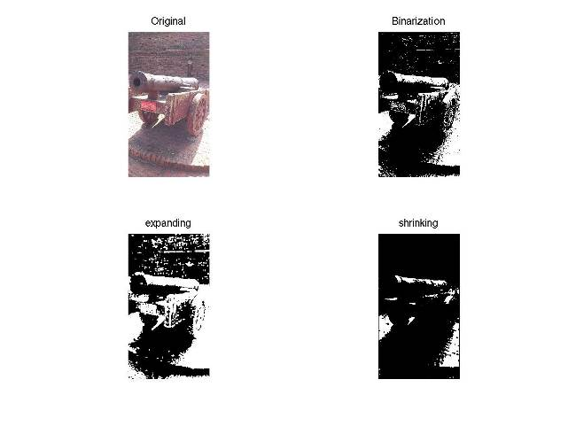

expanding白色部分比原影像多一些，呈現有比較模糊。
shrinking白色部分比原影像少一些，呈現有比較銳利。

